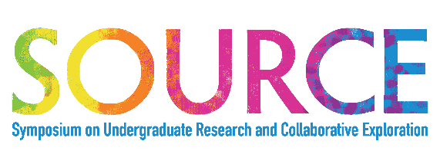
SOURCE Application
Abstract & Poster Information Form
2022 Applications due no later than April 26th to undergradresearch@ccga.edu

Presentation Title:
Insert title exactly as it will appear on presentation
Student Name(s):
Include full name of each student contributing to project, unless whole class is involved
Faculty Supervisor(s):
Include each faculty member if project involves multiple faculty working in collaboration
Semester:
Semester project was completed (E.g., Spring 2022)
Presentation Type:
Choose one: In-Person or Virtual Presentation
Choose one: Poster, oral presentation, panel, faculty/student workshop, gallery, or digital presentation (Video, infographic, paper, PowerPoint, narrated PowerPoint, other: ____):
Abstract:
Limit abstracts to 1200-characters. Fully explain (in a short summary format) your entire project in the text box below. Describe the project (what you did), the impact the project had on your development, and the potential impact the community as a whole (if applicable). Explain the relationship between the project and your career and describe future research opportunities or implications of the project (now what can be done).
All posters and abstracts must be typed and have appropriate grammar and spelling.

