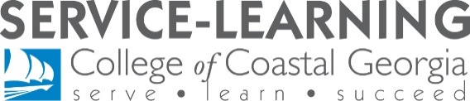
Service-Learning Symposium Poster Showcase Application
Abstract & Poster Information Form
2022 Applications due no later than April 21 to ServiceLearning@ccga.edu

Presentation Title:
Insert title exactly as it will appear on your poster
Student Name(s):
Include full name of each student contributing to project, unless whole class is involved
Faculty Supervisor(s):
Include each faculty member if project entails two service-learning courses working in collaboration
Community Partner(s):
Include full name of organization(s) who collaborated on this project
Semester:
Semester project was completed (E.g., Spring 2018)
Presentation Type:
Choose one: In-Person or Virtual Presentation
Choose one: Poster or digital presentation (Video, infographic, reflective writing/paper, PowerPoint, narrated PowerPoint, other: ____):
Abstract:
Limit abstracts to 1200-characters. Fully explain (in a short summary format) your entire project in the text box below. Describe the project (what you did), community partner you worked with, and impact the project had on you personally and on the community as a whole (why it was important). Explain the relationship between the project and your Service-Learning Outcomes and describe future implications of the project (now what can be done).
All posters and abstracts must be typed and have appropriate grammar and spelling.

